Review
Last time we focused on:
- moving
Important for staring sprites out where you want them
best when moving in only one direction (e.g., using arrow keys)
- sensing
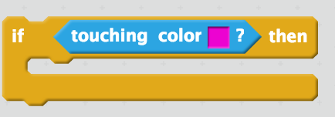
Look in “sensing” for other things you can test for. Think about how you might use them.

Today’s Concepts
More movement
 (we will use this again, with the arrow keys)
 (we will use this for sprites that move automatically)
(to keep “robot” sprites from going off screen)
More sensing
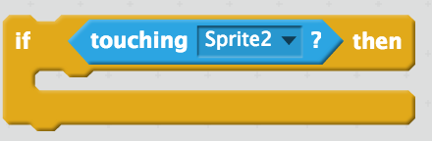(see if one sprite is touching another)
Variables
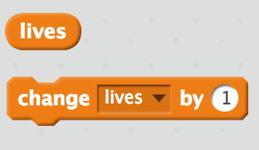(a way to keep track of things that aren’t shown on the screen)
Random numbers
(use anywhere that you might like to pick a random number)
And looping (or “iteration”)
(do something continuously, as long as the program is running)

Today’s Project: Make a Dodging Game

1. Create a Sprite. Name this one “dodger.” Pick clip art from the Scratch Costume Library that you want to use. Don’t spend more than one minute choosing. Get rid of the cat.
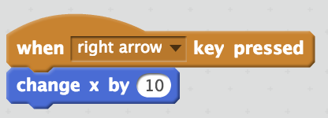
2. Make dodger move with the arrow keys. This is the same as last week, except without the sensing. Like this:

3. Create another Sprite. Name this one “rock.” Pick a costume that looks rock-like. 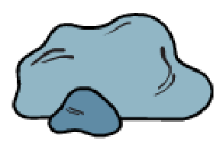(whatever’s cool)

4. Make “rock” move continuously, and bounce when it hits an edge. You will need these blocks:

5. Make it so that when the rock hits dodger, dodger says “ouch” for a second or two.

6. Now make it so that dodger loses a life when hit by the rock. Start with five lives, and make the game end when lives reaches 0.
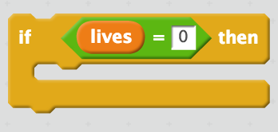
7. Is there a bug? Does dodger lose too many lives when hit? Why is this happening? Write your thoughts.

____________________________________________________________________________

____________________________________________________________________________

What do you think you could do to fix this? Write down an idea or two:

____________________________________________________________________________

____________________________________________________________________________

____________________________________________________________________________

8. Here’s one idea, try this one:
As soon as rock hits dodger, make rock disappear and reappear somewhere else. The place where rock appear should be random.
Make sure you understand how this works and why we are using it!

9. Now you have a basic version of the game working. List 2-3 ideas to make the game more challenging:

____________________________________________________________________________

____________________________________________________________________________

____________________________________________________________________________

Here are some ways to make it more challenging, try these:

10. Add a third sprite, rock 2, that is smaller and faster than rock. Make sure that rock2 starts out at a different angle and from a different position than rock.


11. Add 3 more sprites, names walk 3-5. Make it so that every 10 seconds a new rock appears, with greater speed than the last one.

12. Add a way for dodger to gain back lives. Have an apple (or something) appear from time to time, briefly, in random locations. If dodger “eats” the apple, a life is added.

13. Now adjust the settings to make the game challenging but not impossible. You can play around with:
- rock speed
- rock size
- dodger speed
- dodger size
- apple frequency
- apple duration

